OIC Oracle Managed DR.
Test case: is OIC schedule automatically migrated in secondary OIC instance when Failover is performed ?
Test done in:
- Tenancy: emeaadsappdevint
- Compartment: gconte
- Oic instance: oic3_dr_primary
- Primary region: Frankfurt
- Secondary region: Amsterdam
Following are file server details.
Schedule:
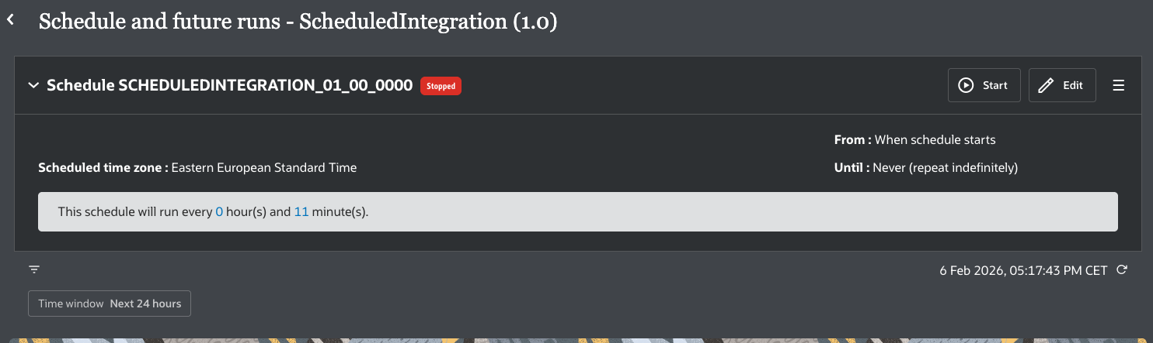

Schedule started in Frankfurt region.
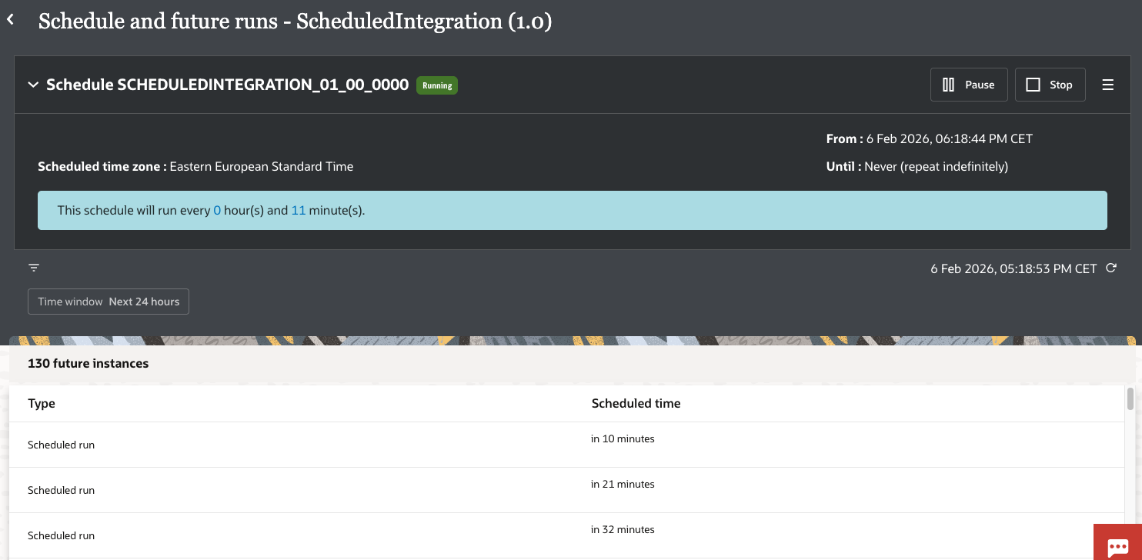

Next check
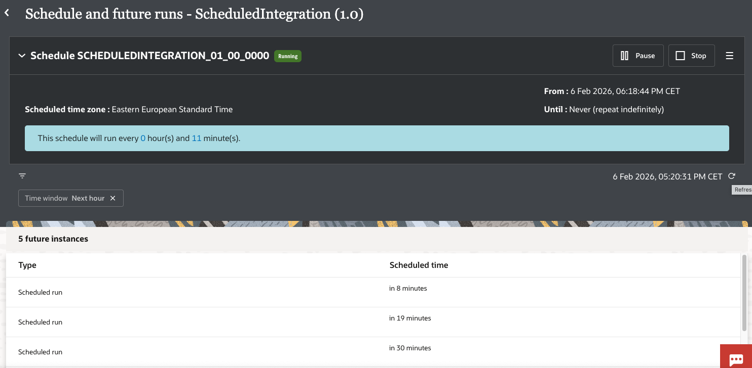
We expect that around 05:29 it will start queuing.

Now checking (see timing on screenshot)

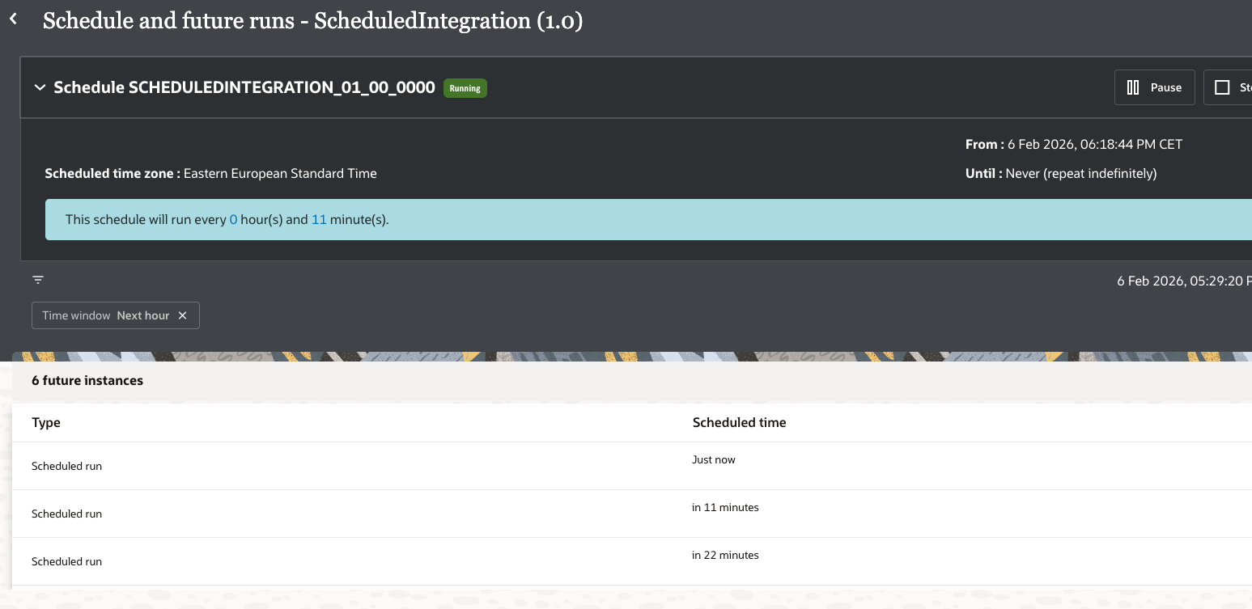

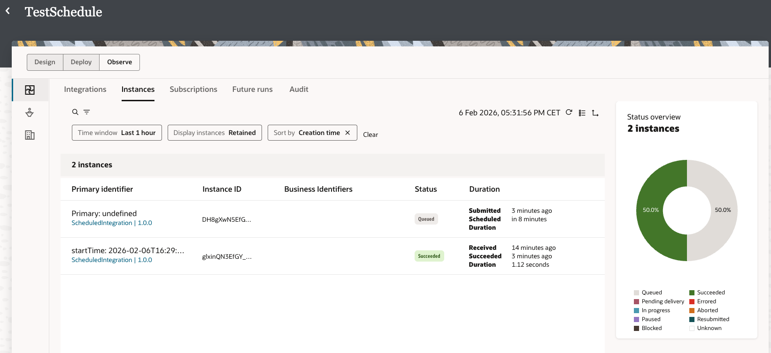

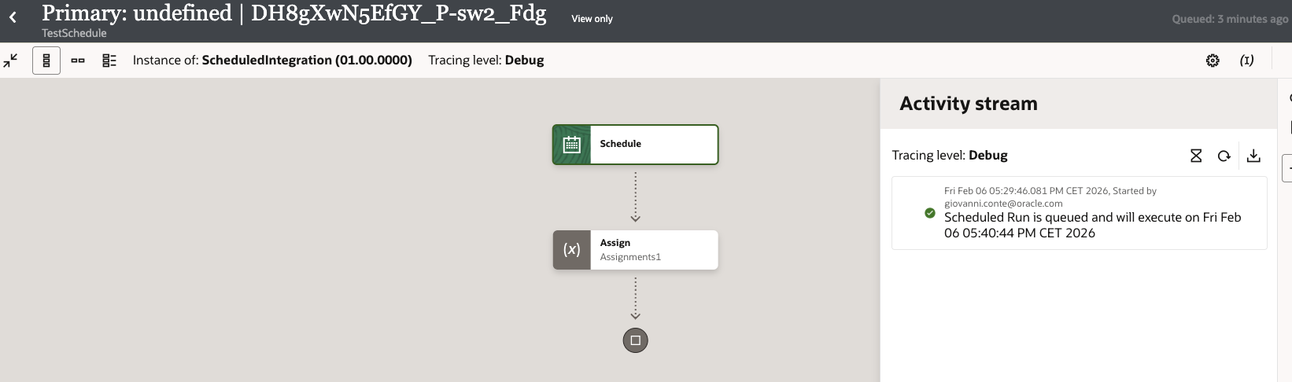

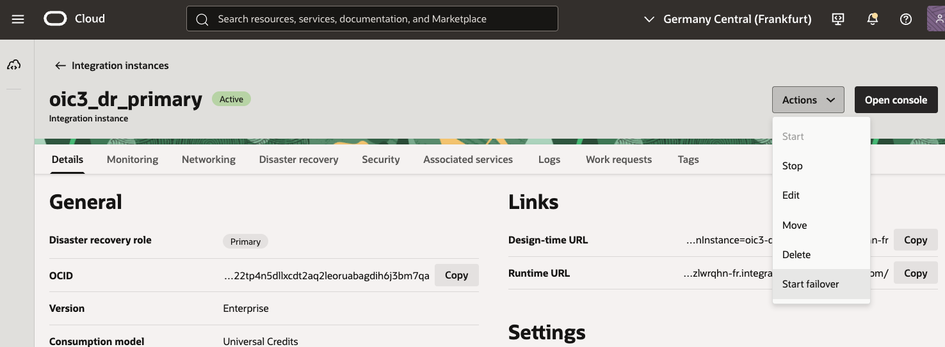

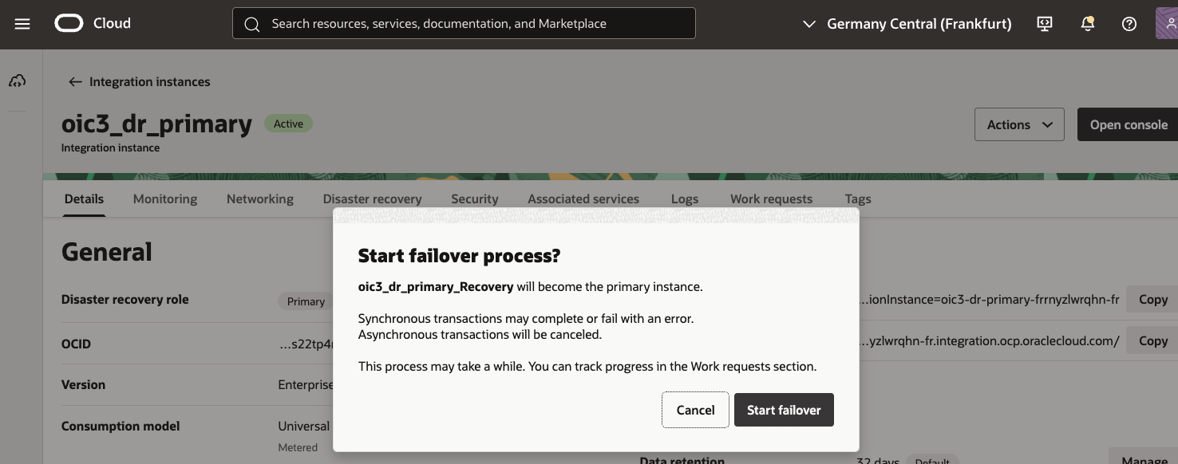

Failover running.
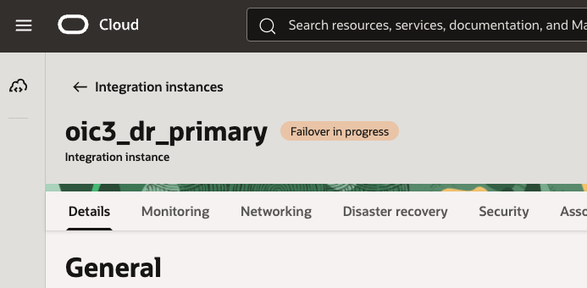

View of instance in Frankfurt Region.

View of OIC instance in Amsterdam region after Failover completion.

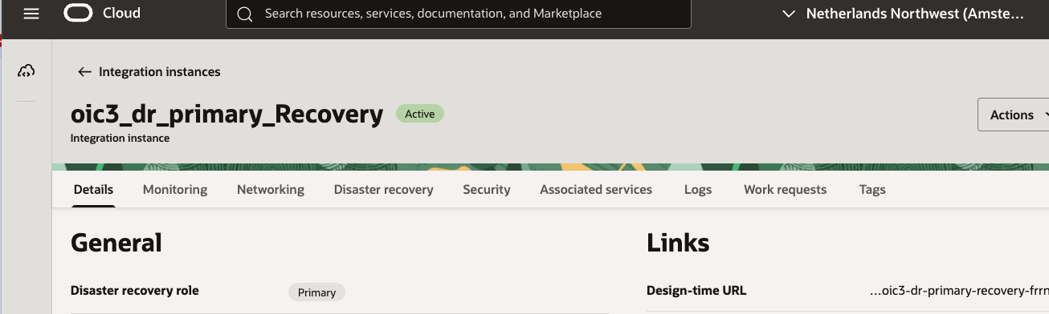

Now checking the schedule.
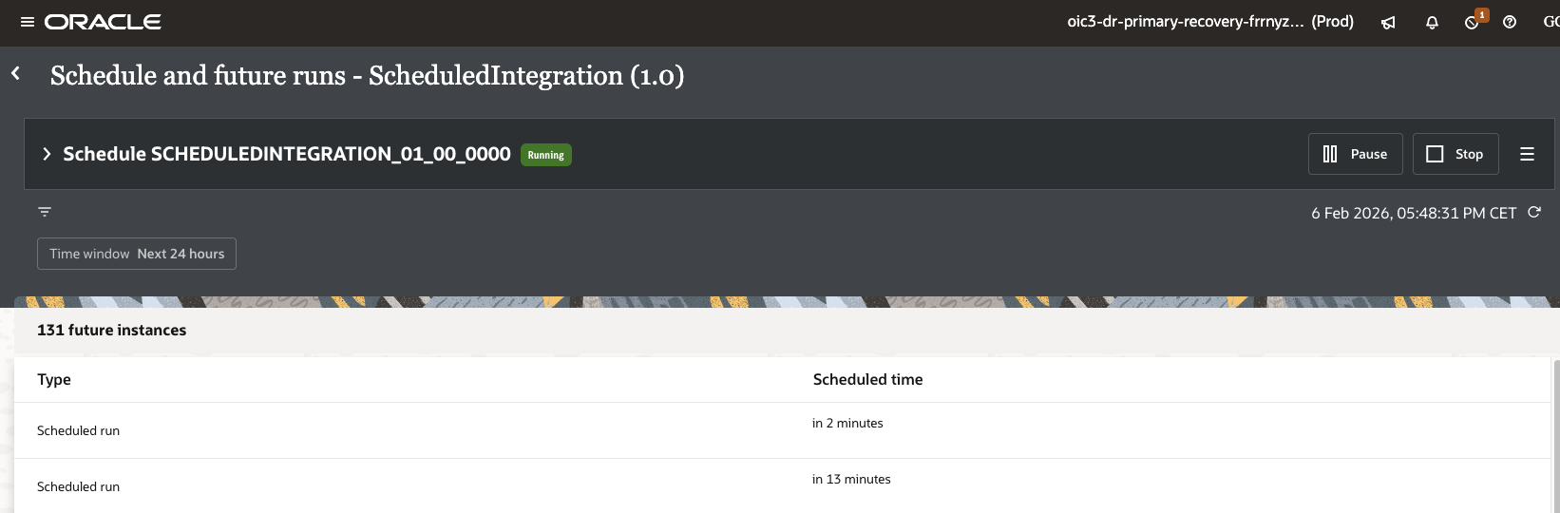

It is active as it was let in Primary.
We got the execution scheduled for 5:40:44
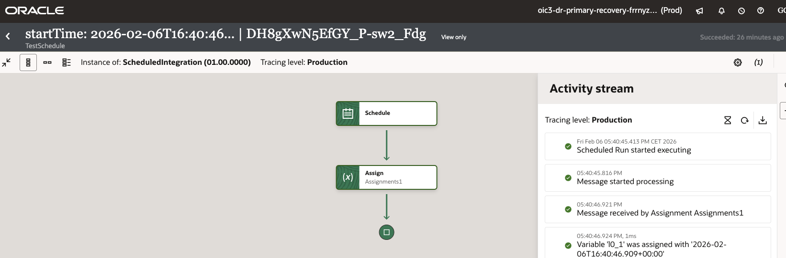

And now we are getting the schedule for 5:51:44 which is correct.

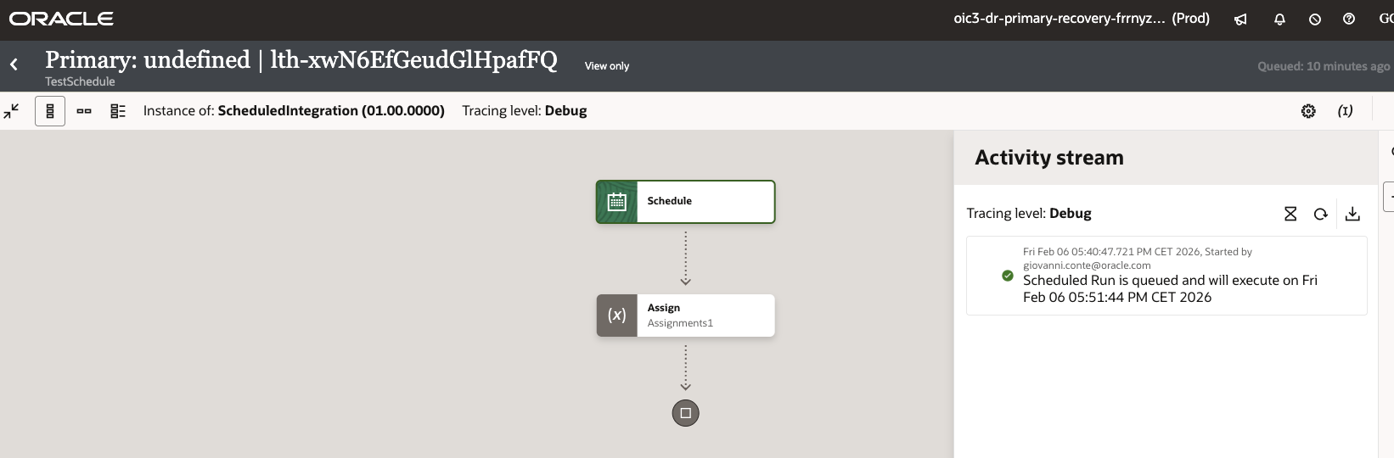
The at 5:51 it is executed

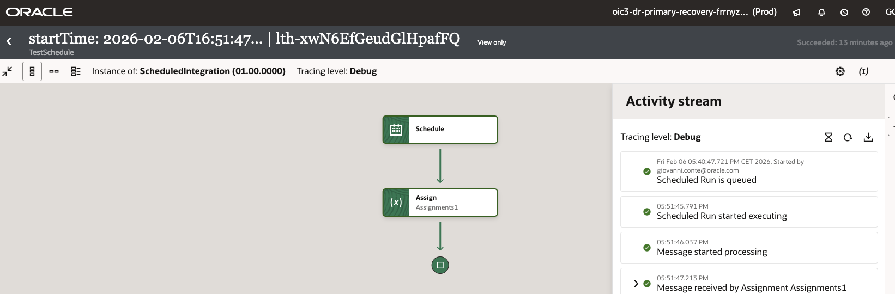

Added a new scheduled integration (scheduledIntegration2) and its schedule (every 10 minutes).
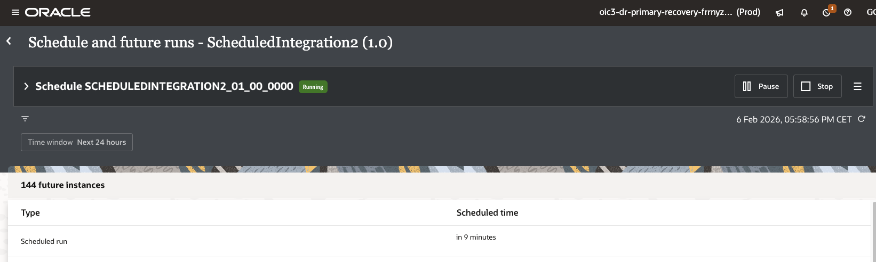

Performing the switchback to Primary very close to schedul execution (2 minutes left) so almost sure this schedule, expected for 6:08:52 will not run and will be skipped.

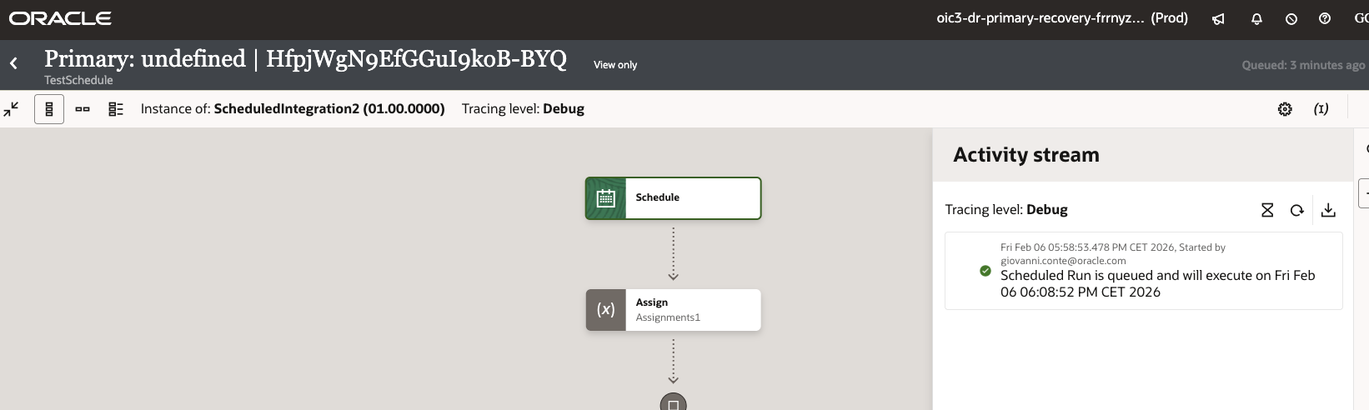
Now performing switchback from Amsterdam secondary instance. The above mentioned scheduled integration was in the following status:
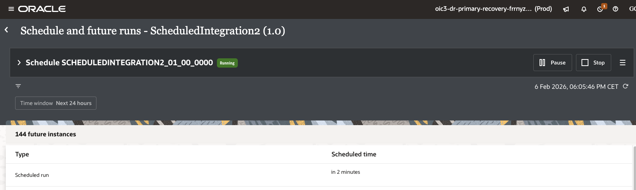

View of instance in Amsterdam Region.

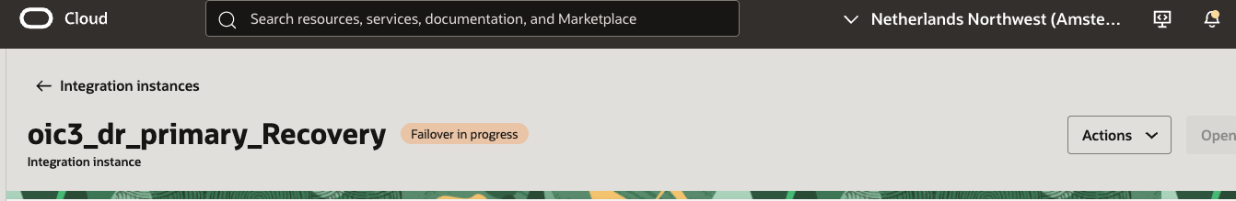

View of instance in Frankfurt Region.

When OIC is Active in Frankfurt, I check again the schedules.
Checking schedules and sheduled integration we did not find the ScheduledIntegration2 created in Secondary available (migrated) in Primary instance.

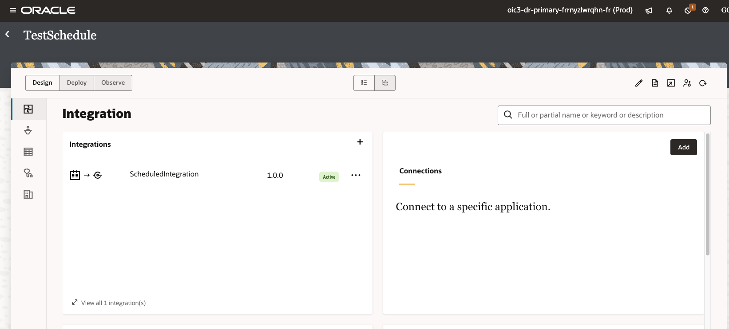

We see ScheduleIntegration still scheduled.
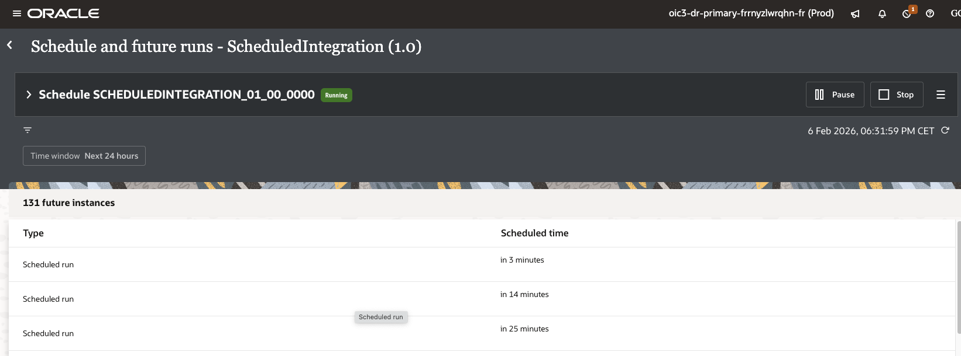

And first executed schedule.
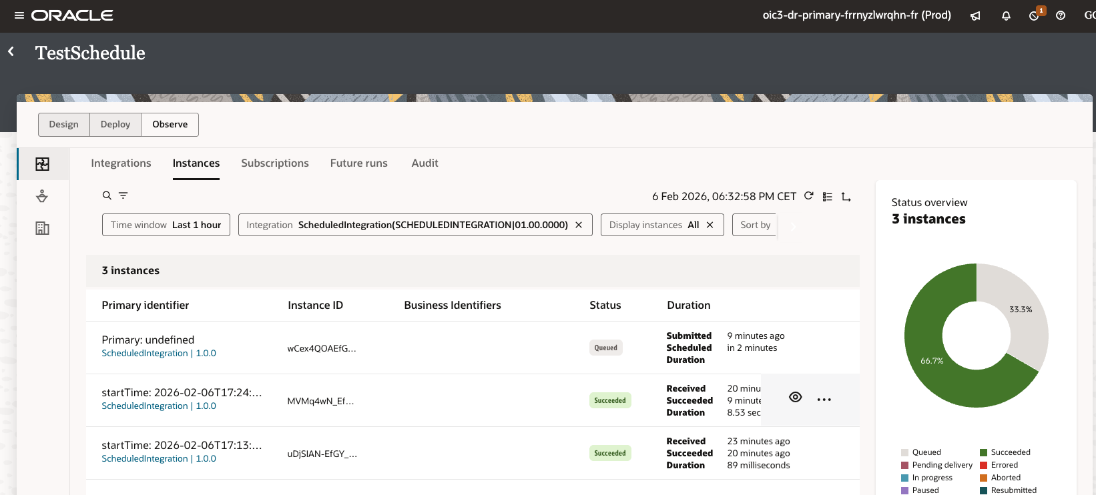

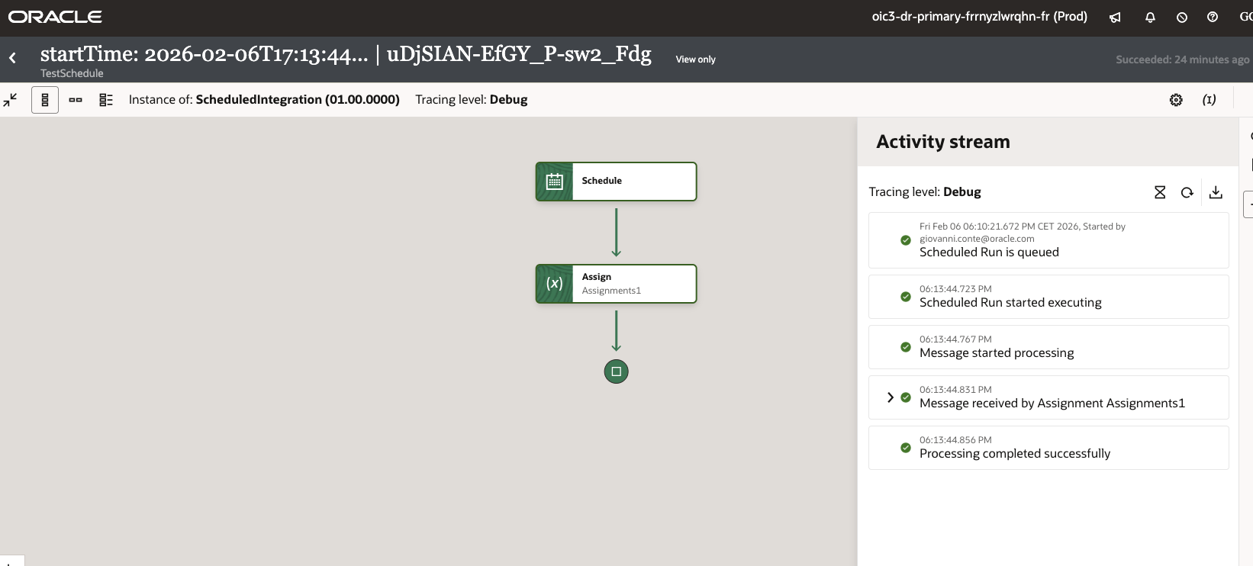

Now, checking something more on ShceduledIntegration2.
Switched back again in Secondary and found the it is still there.

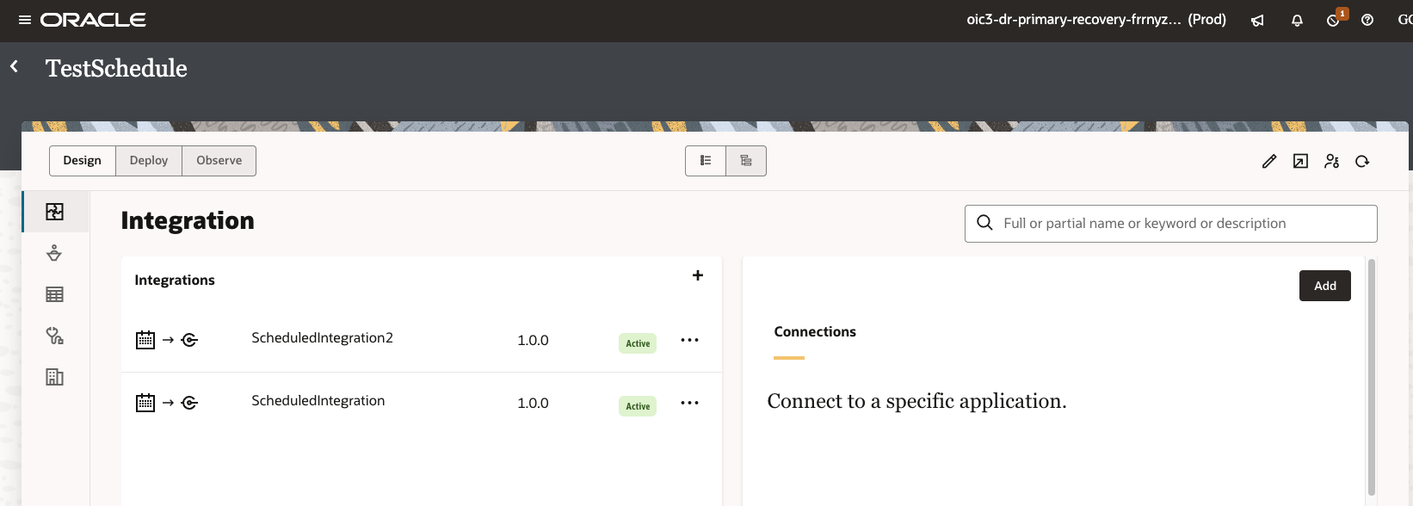

And its scheduled are active.

